GENERAL THINGS

1-) Renewable energy solutions are becoming cheaper, more reliable and more efficient every day.Our current using on fossil fuels is unsustainable and harmful to the planet, which is why we have to change the way we produce and consume energy.

2-) And why we still use fossil fuels?

People get used to use fossil fuel. For example companies and other brands still use fossil fuel like coal, gas, et cetera

Some European countries such as russia ukraine and turkey have increased their use of fossil fuels because of war and other reasons so they postpone sdg’s goals.

-some European countries plan to speed up the transition to renewable energy, while some other countries plan to increase the use of coal, putting the green transition at risk

3-) Using these new energy solutions is essential to counter climate change, one of the biggest threats to our World.

4-) Total renewable energy consumptıon increased by a quarter between 2010 and 2019 but progress in energy effıcıency has to be speed up to reach goals because it has improved so slowly

5-) And ı can prove it with this information there are still over 700 million people globally living in the dark and they are generally living in the sub-saharan africa

5-) İt requires significant efforts to reach poor, weak and other people who live in bad conditions and we need to do more things for them.

5-) So ı mean for renewable energy technology to be a global public good – should be available to all, and not just to the wealthy. Not just rich people we sould all be able to use it.

AIMS

Aim 1 - By 2030, ensure universal access to affordable, reliable and modern energy services

Aim 2 - By 2030, enhance international cooperation to facilitate access to clean energy research and technology, including renewable energy, energy efficiency and advanced and cleaner fossil-fuel technology.

Aim 3 - By 2030, it aims to increase the use of renewable energy all over the World

Aim 4 - By 2030, double the global rate of improvement in energy efficiency

Last words

UN secretary-general António Guterres said that “The good news is that the lifeline is right in front of us.” And he explained this idea renewable energy technologies like wind and solar already exist today and they are cheaper than coal and other fossil fuels. We should use them instead of using fossil fuels.

I agree with Antonio guterres because it is more sense. Really some cheaper renewable energy sources already exist why we dont use them?

I will end my presentation with the words of Antonio Guterres “without renewables, there can be no future.”

THİNGS TO Do

More than 2,000 participants at the UN Climate and SDG Synergies Conference, held in Tokyo and virtually on 20-21 July, generated an impressive range of potential solutions and proposals for how to better integrate efforts to tackle these interlinked global crises and accelerate action to address the climate emergency and recent reversals in achieving the Sustainable Development Goals.

Featuring over 100 speakers from around the world, including more than 30 government Ministers and other high-level officials.

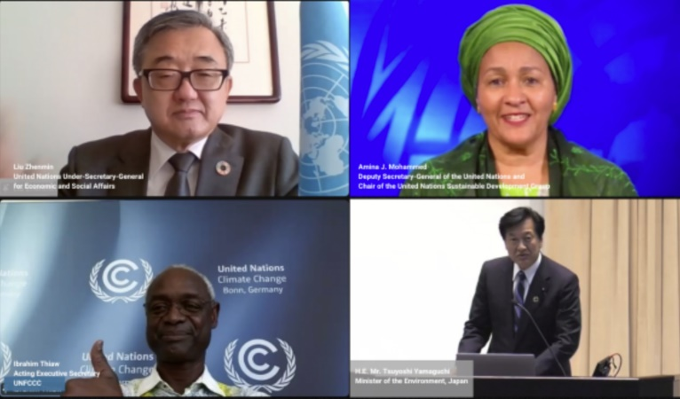

-Use solar energy sources. Install solar panels in your home for your heating and electricity. Use solar technology – radio, charger, lights etc…

-Buy rechargeable electronics. Don’t buy or use one-use batteries.

-Switch off your appliances at the socket. Turn off the lights when you’re not using them

-Essential technologies such as battery storage systems allow energy from renewables, like solar and wind, to be stored and released when people, communities and businesses need power. They help to increase energy system flexibility due to their unique capability to quickly absorb, hold and re-inject electricity

-Fossil-fuel subsidies are one of the biggest financial barriers hampering the world’s shift to renewable energy.

-Fossil fuel subsidies are both inefficient and inequitable. Across developing countries, about half of the public resources spent to support fossil fuel consumption benefits the richest 20 percent of the population, according to the IMF.

-Shifting subsidies from fossil fuels to renewable energy not only cuts emissions, it also contributes to the sustainable economic growth, job creation, better public health and more equality, particularly for the poor and most vulnerable communities around the world.